Assignment of Ruby on Rails

Github : Blog_App

1. INTRODUCTION TO RUBY ON RAILS APPLICATION
Ruby on Rails (often called Rails) is a full-stack web application framework that follows the Model–View–Controller (MVC) architecture.
It emphasizes Convention over Configuration and Don’t Repeat Yourself (DRY) principles, allowing developers to build scalable applications quickly with minimal boilerplate code.

1.1 CREATION OF A NEW RAILS APPLICATION

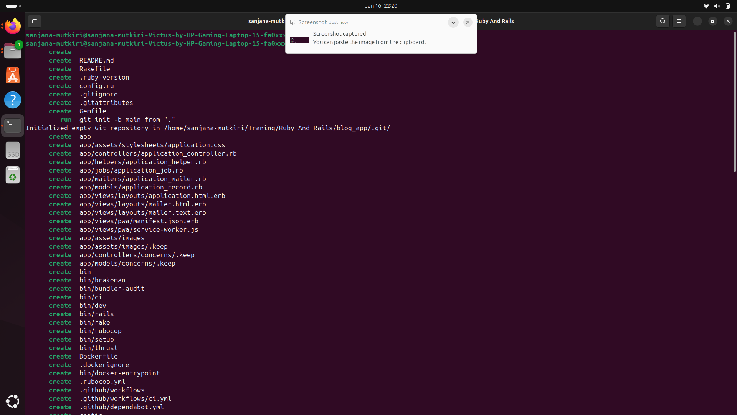

1.2 What Rails Generates by Default

Folder | Purpose
app/ | Main application code
app/models | Business logic + DB interaction
app/controllers | Handles HTTP requests
app/views | UI / HTML responses
config/ | App configuration
db/ | Database + migrations
log/ | Request & error logs
Gemfile | App dependencies

1.3 Push Initial Setup to Git

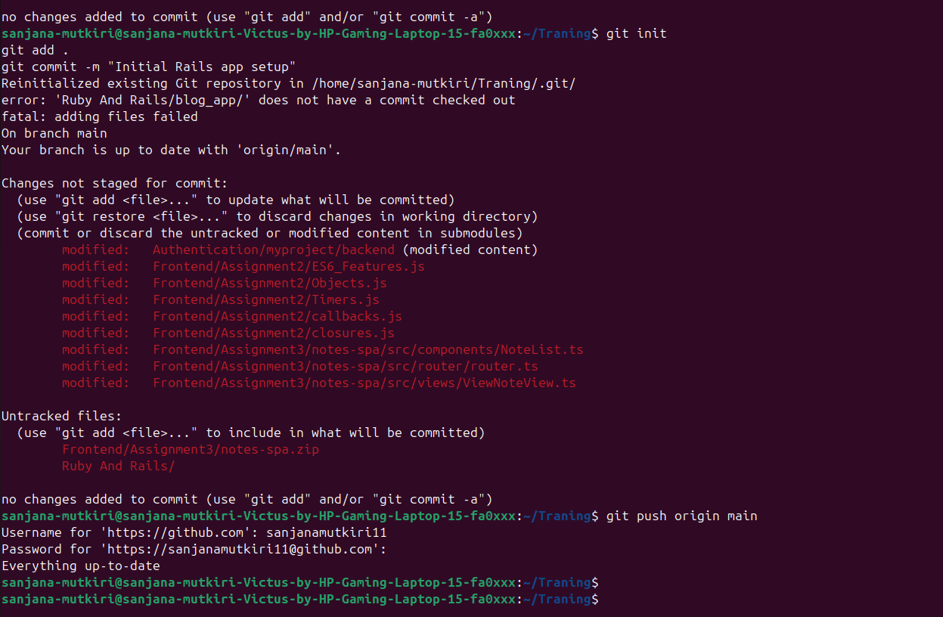
A new Rails application named blog_app is created using the Rails application generator.

1. 4 Explore Rails Guides
- Sets up the entire application skeleton
- Configures database connectivity
- Initializes middleware, routing, logging, and dependency management
- Enforces Rails best practices from the start
Rails automatically generates a ready-to-run application, which demonstrates Rails’ philosophy of developer productivity.

2 FOLDER STRUCTURE & REQUEST LIFECYCLE

When a Rails application is created, several folders are generated, each having a specific responsibility.

app/
This is the core folder of the application.

app/models
- Contains business logic and database interaction
- Responsible for validations, associations, and data rules
- Keeps database logic separate from user interface and request handling

app/controllers
- Handles incoming HTTP requests
- Coordinates between models and views
- Decides what data to fetch and which response to send

app/views
- Responsible for rendering the user interface
- Uses embedded Ruby (ERB) templates
- Keeps presentation logic separate from business logic

config/
- Manages routing, environment settings, database configuration
- Central place for application-wide configurations

config/routes.rb
- Maps URLs to controller actions
- Enables RESTful architecture
- Provides a clean and readable routing mechanism

db/
- Contains database schema changes
- Stores migrations and seed data

db/migrate
- Tracks changes to database structure over time
- Ensures database consistency across environments

2.1 Generate Blog Scaffold

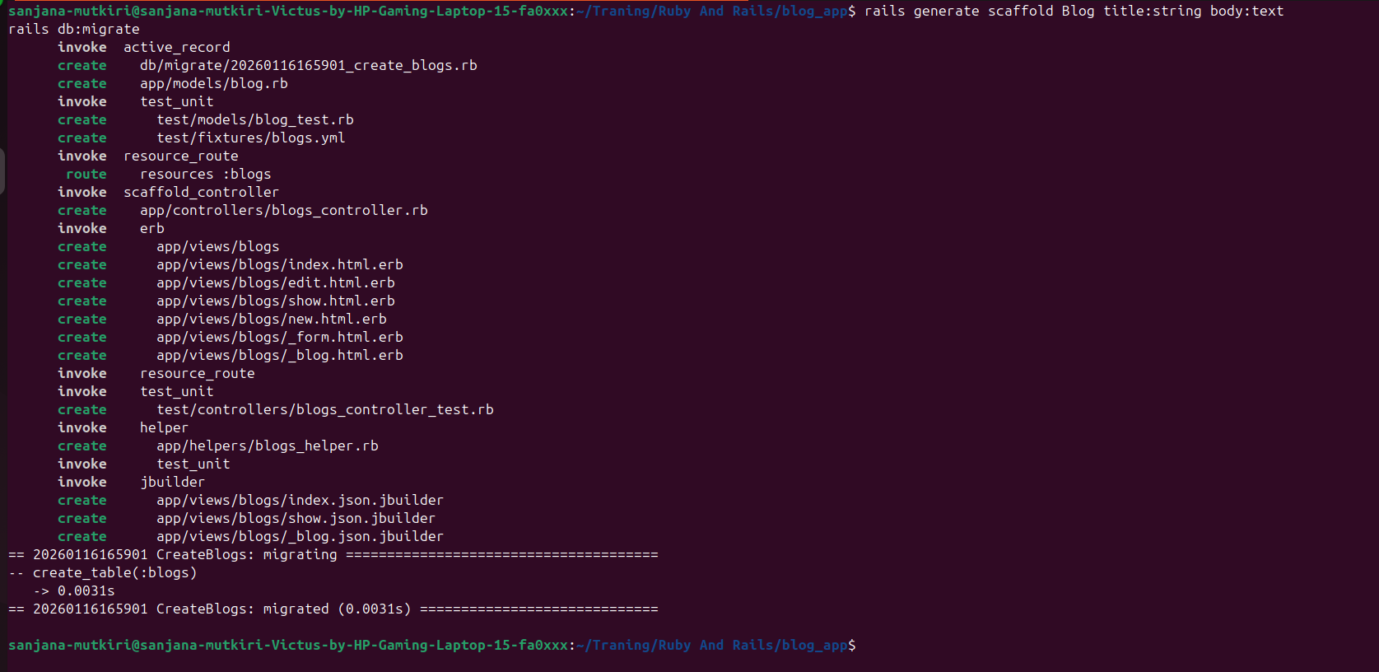

Creates:
- Model
- Migration
- Controller
- Views
- Routes
- Tests
WHY?
- Fast prototyping
- Teaches Rails conventions automatically

2.2 Explore Rails Structure

app/controllers/blogs_controller.rb
Handles requests like:
- GET /blogs
- POST /blogs

app/models/blog.rb
Handles:
- DB queries
- Validations
- Associations

app/views/blogs/
HTML files rendered to users.

db/migrate/
Contains DB schema changes.

2.3 Trace Request Lifecycle

Start Server : rails server

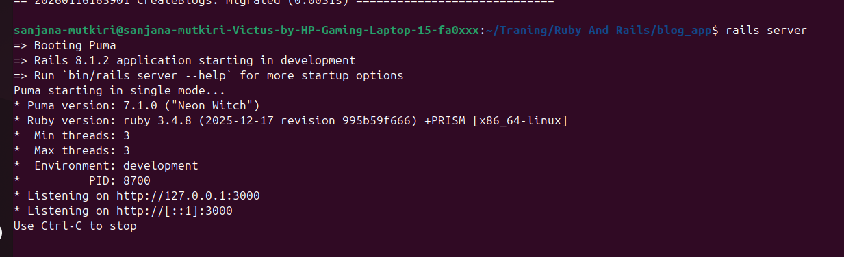

http://localhost:3000/blogs

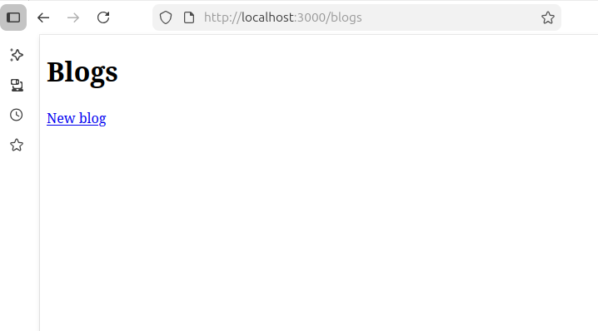

Check logs

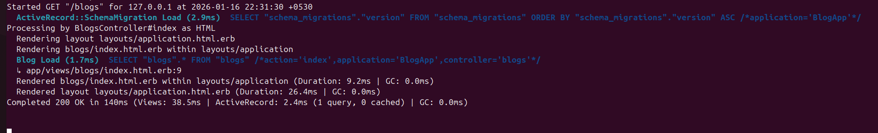

Request Flow

Browser
→ routes.rb
→ BlogsController#index
→ Blog.all
→ index.html.erb
→ HTML response

3. Models

Comment Model
A Comment model is created to represent user feedback on blogs.

Relationship:
- A Blog has many comments
- A Comment belongs to a Blog

Why associations are important:
- Reflect real-world relationships
- Enable intuitive data access
- Enforce referential integrity

3.1 Create Comment Model
Creates: blog_id and belongs_to association

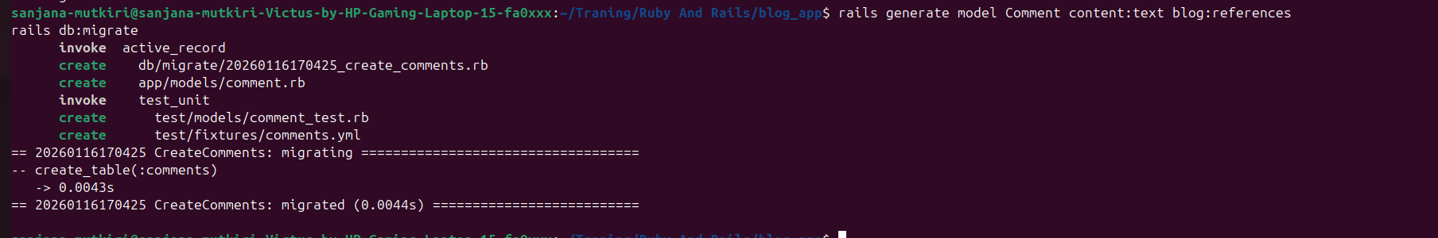

Updated blog .rb

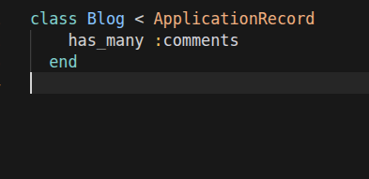

Updated comment.rb

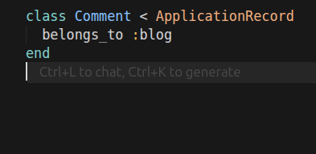

3.2 ActiveRecord Helper Methods
Rails adds automatically:
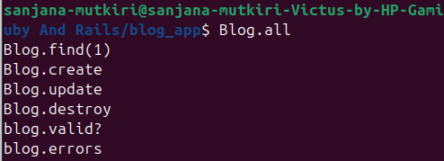

3.3 Add published Column

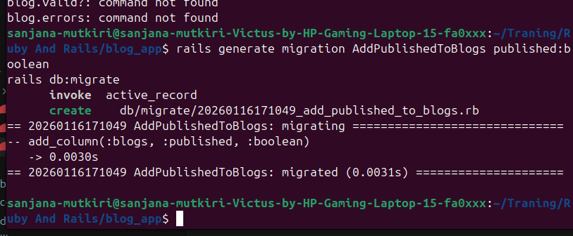

3.4 Migration Helpers

Performance (index)
Schema refactoring (rename)

3.5 Add Scope

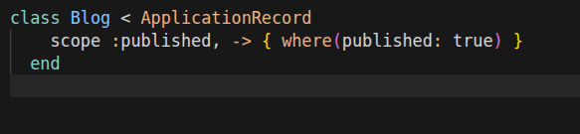
scope defines a class-level method on the Blog model

3.6 VALIDATIONS
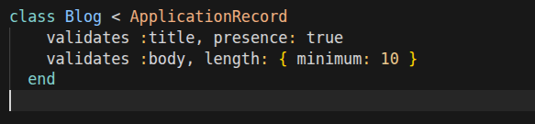
Before saving a blog record:
Rails checks if title exists
Rails checks if body.length >= 10
If validation fails:
- Record is NOT saved
- Errors are stored in errors object
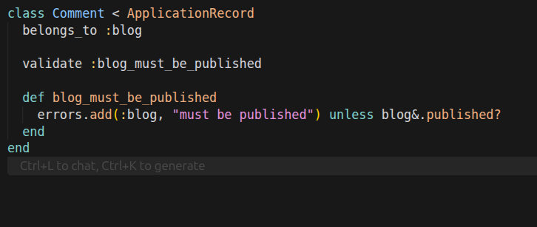

3.7 VERIFY VALIDATIONS USING RAILS CONSOLE
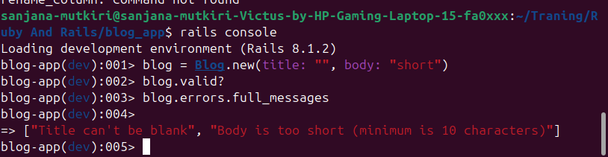
- valid? triggers all validations
- Rails checks:
title presence and body length

Since validation fails:
valid? returns false and Errors stored in memory

3.8 ACTIVERECORD QUERY METHODS

Rails builds SQL dynamically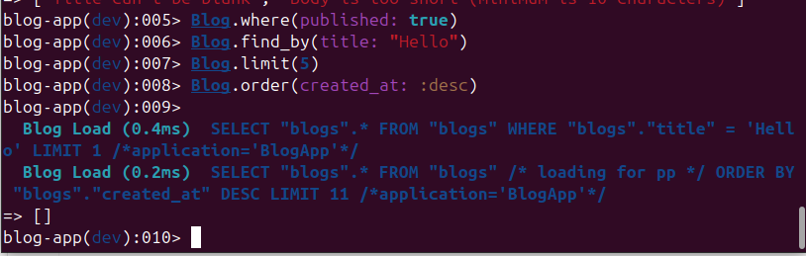
includes

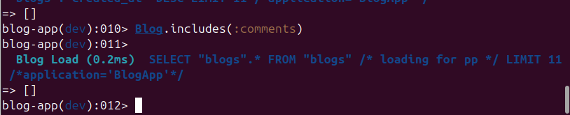 eager_load
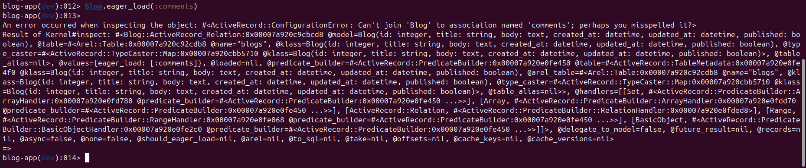

3.9 SEEDS

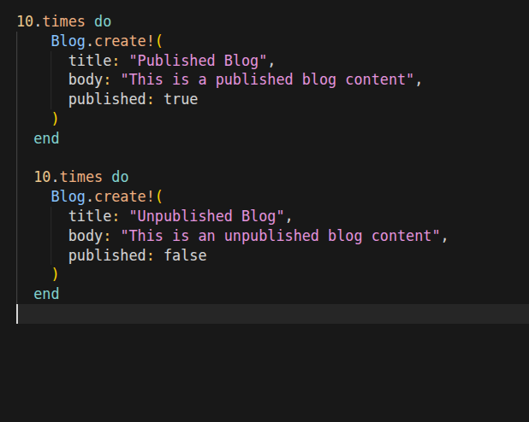

Rails loads seeds.rb
Creates records in DB
Uses validations and callbacks
Fails loudly if invalid (create!)

4 Controllers
Controllers manage the flow of data between models and views.
RESTful routes:
1 Follow HTTP standards
2 Improve API readability
3 Encourage consistency
Nested routes for comments:
1 Reflect parent-child relationship
2 Maintain URL clarity

4.1 RESTful Routes for Comments
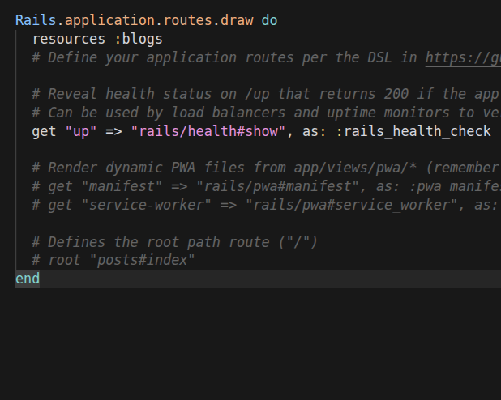

4.2 Verify Routes

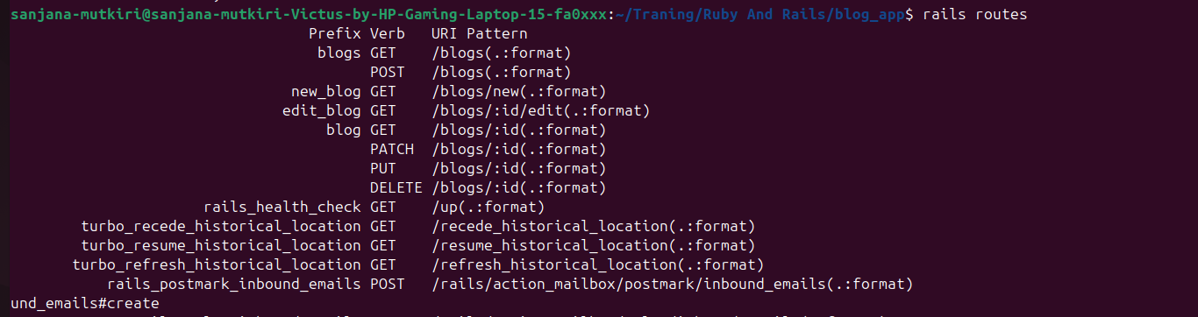

4.3 resources vs resource

resources | resource
many | single
/users | /profile

4.4 namespace vs scope
namespace :admin:
- Automatically adds /admin to the URL
- Automatically expects controllers inside Admin module

Scope
URL grouping

4.5 before_action Callback

Runs set_blog method before the show action
Loads the blog record into @blog

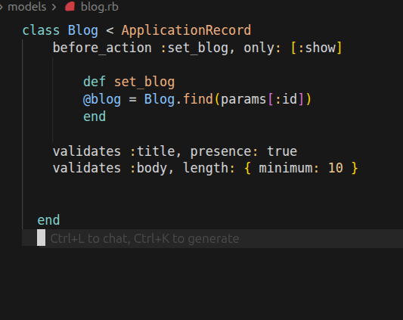

4.6 Strong Parameters

Filters incoming request parameters
Allows only safe attributes to be saved

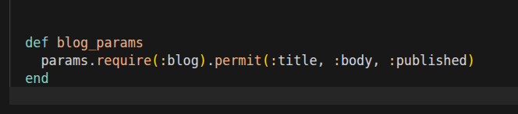

Rails internal Working

{
"blog": {
"title": "Hello",
"body": "Content",
"published": true,
"admin": true
}
}

4.7 Show Only Published Blogs

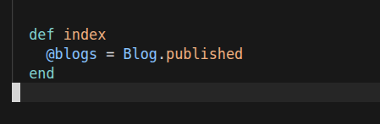

Calls Blog.published
Scope translates to SQL
Only published blogs are returned
View renders safe content

4.8 Publish API

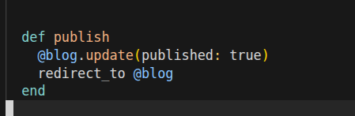

Changes the blog’s state from draft to published
Redirects user to blog page

